MICROSERVICE USING MAVEN

Step 1: Set up Spring Boot microservices

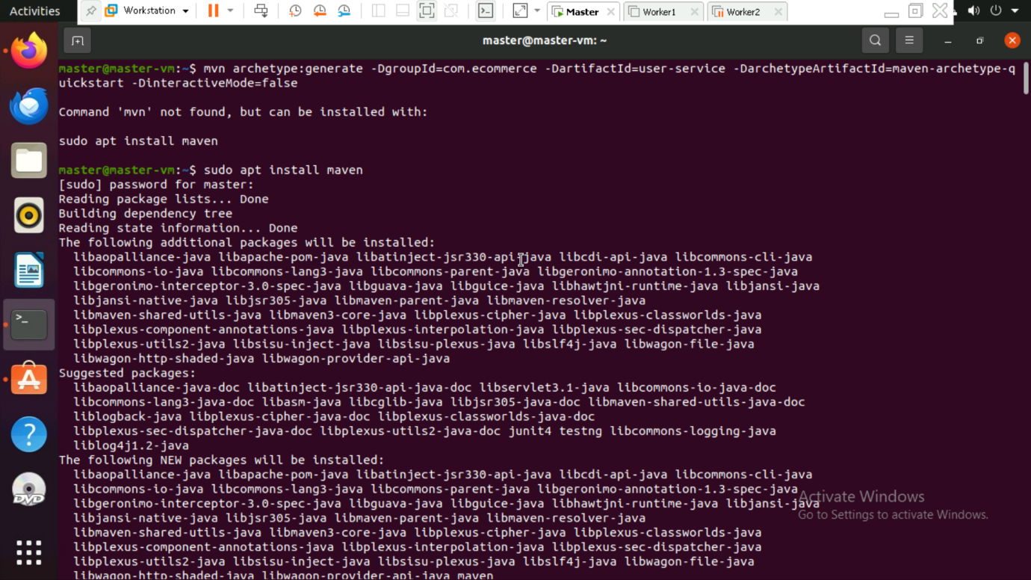

Step 2: Set up Spring Boot microservices

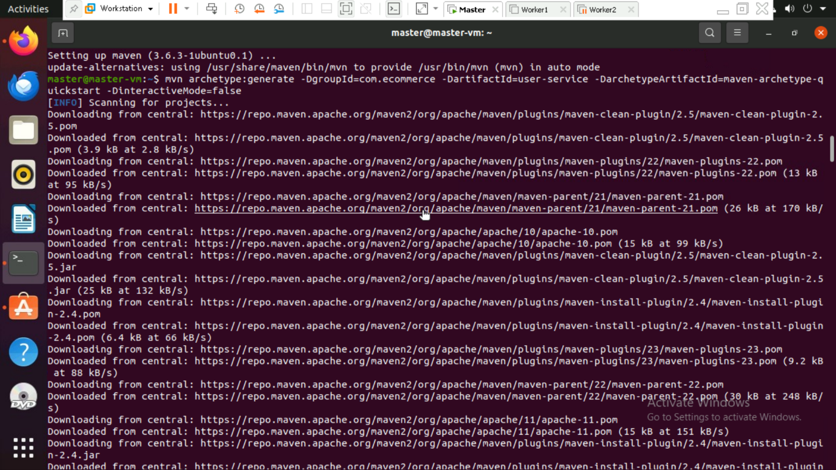

Step 3: Set up Spring Boot microservices

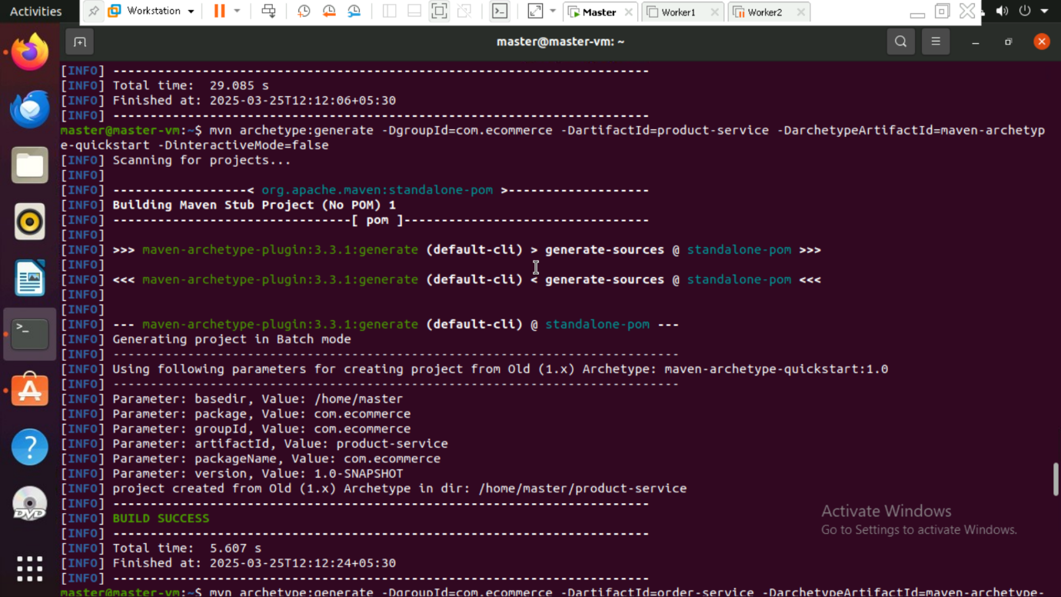

Step 4: Set up Spring Boot microservices

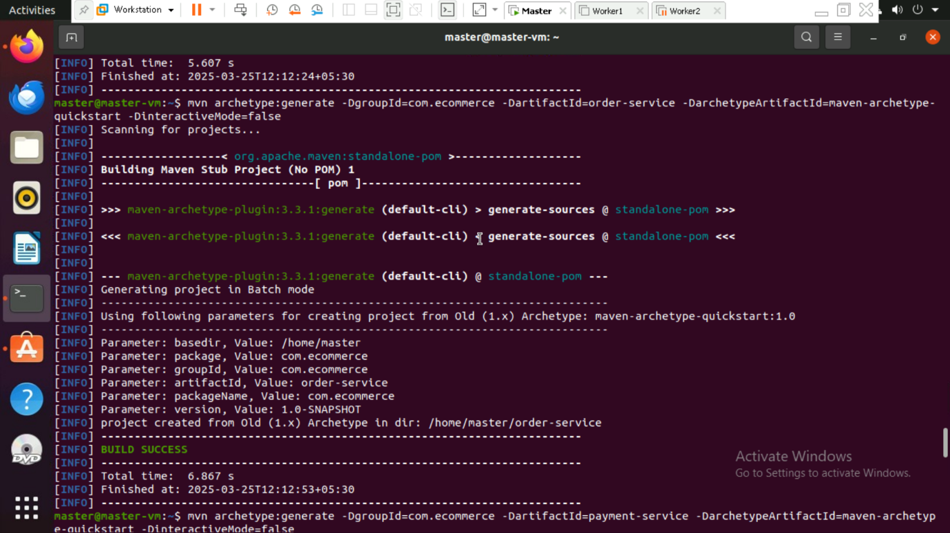

Step 5: Set up Spring Boot microservices

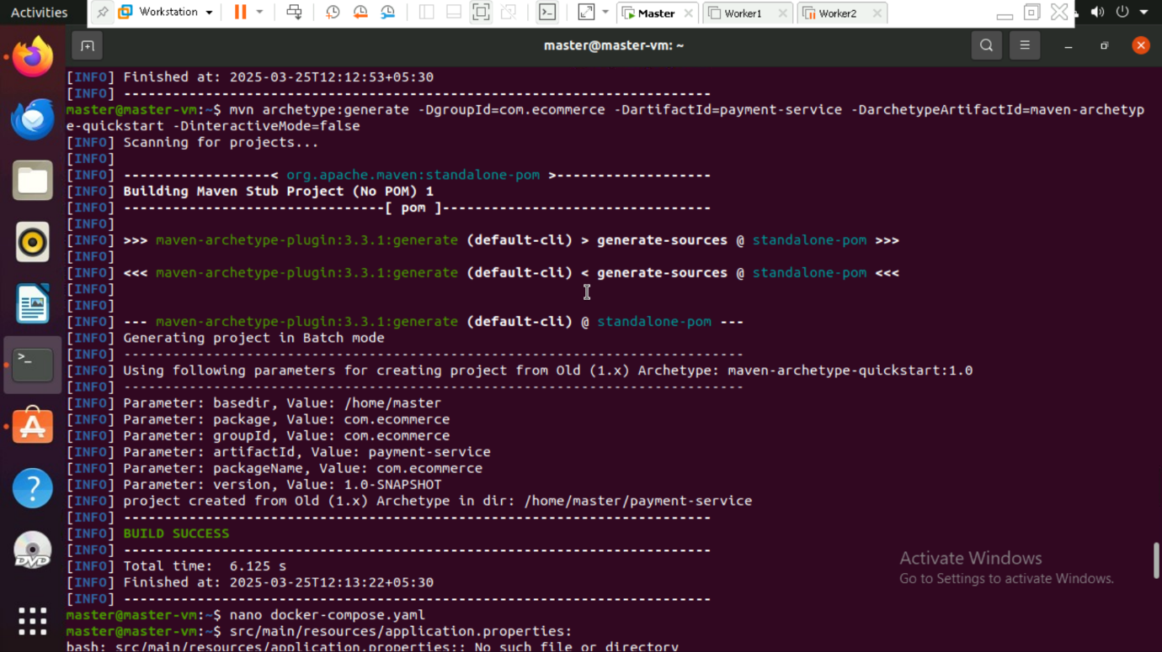

Step 6: PostgreSQL Configuration in docker-compose.yml



Step 7: Database Connection in application.properties

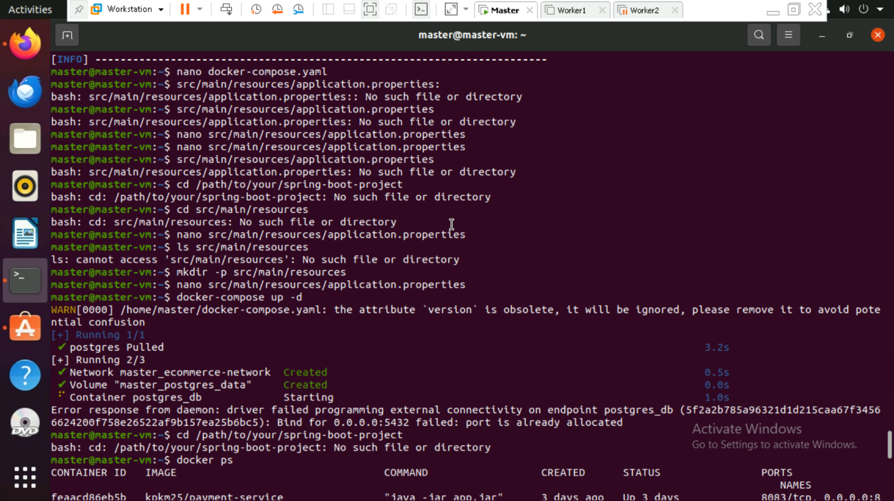

Step 8: Running PostgreSQL with Docker Compose

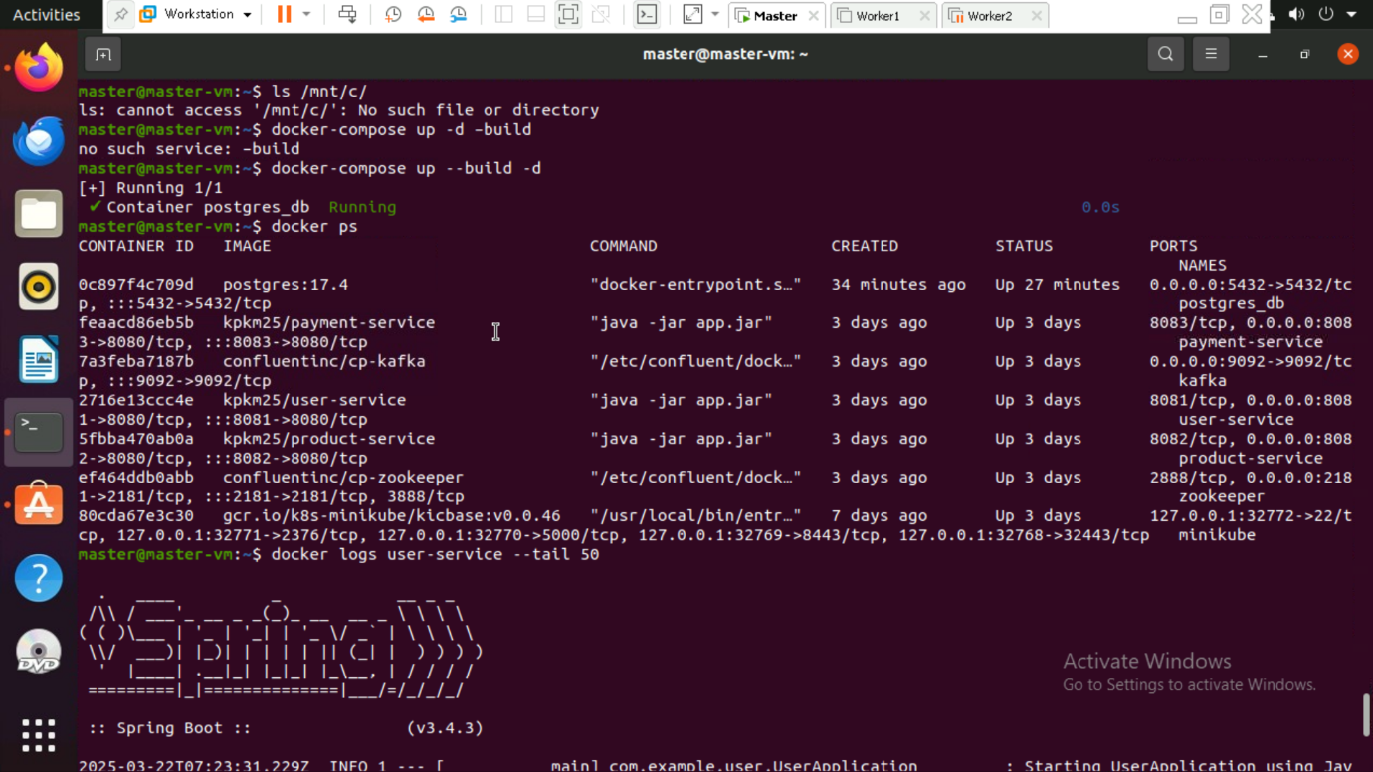

Step 9: Check running containers

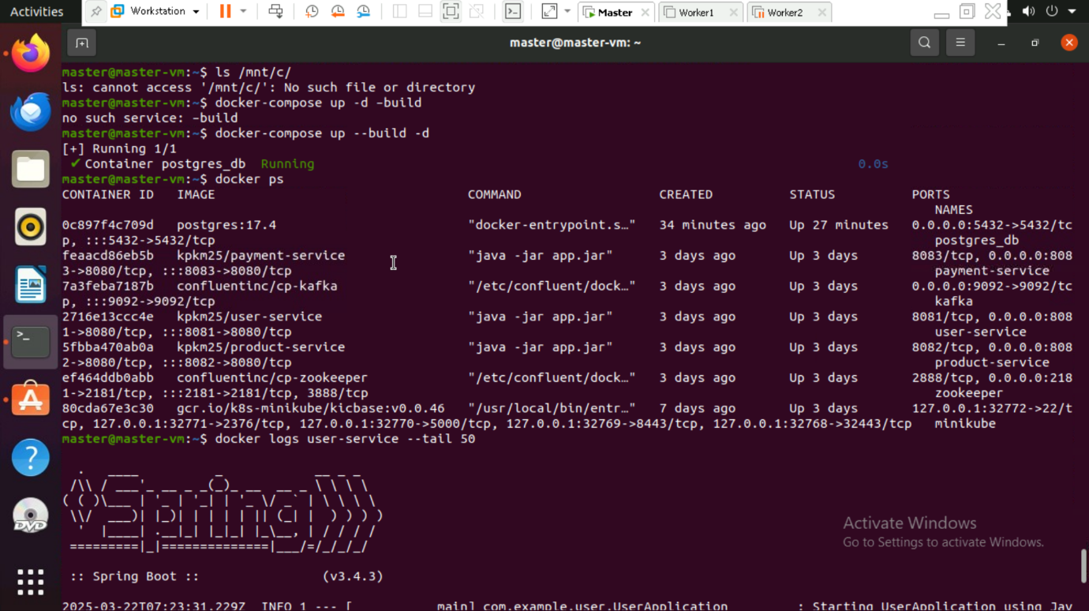

Step 10: Check logs for a specific service

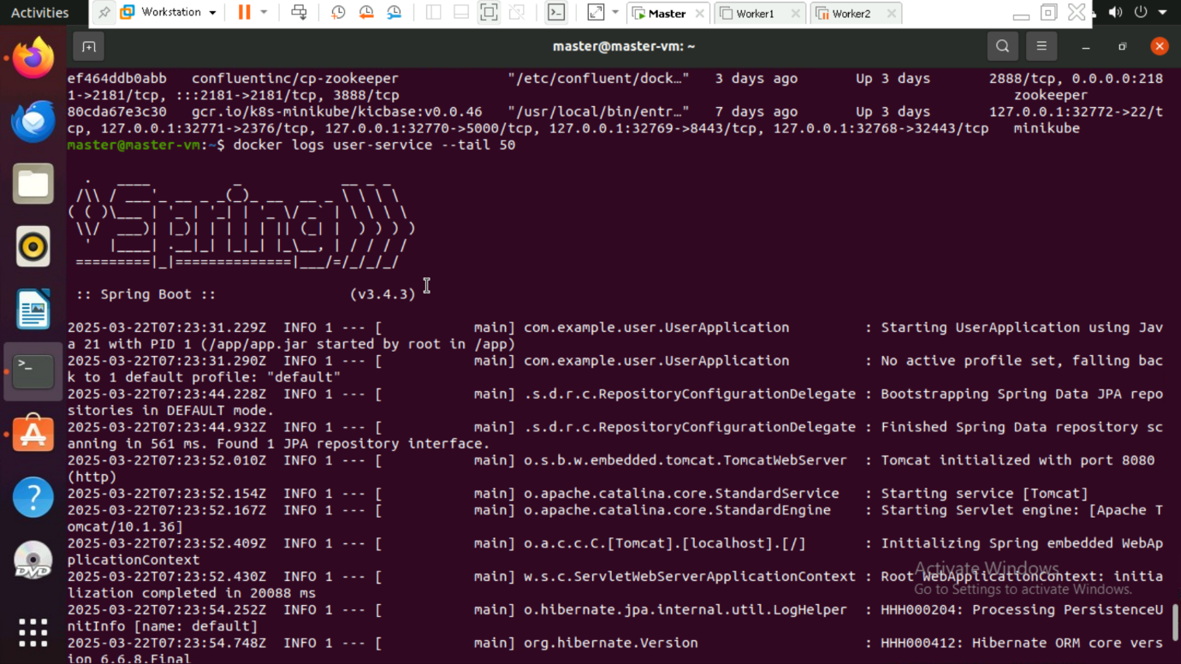

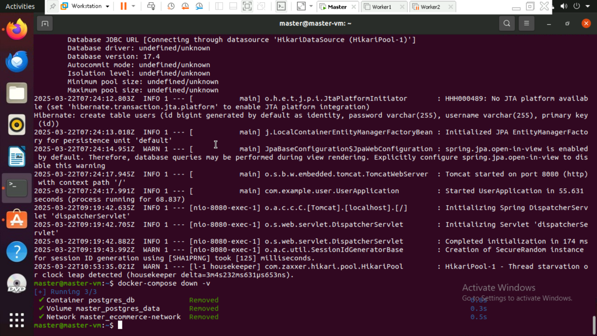

Step 11: To stop and remove all services

